**[Django](https://www.geeksforgeeks.org/django-tutorial/)**is a Python-based web framework that allows you to quickly create efficient web applications. If you are new to Django then you can refer to[Django Introduction and Installation](https://www.geeksforgeeks.org/django-introduction-and-installation/?ref=lbp). Here we are going to learn How to create a Django project using Firebase as Database.

**How to create a new project in Firebase?**

**Step 1:**Firstly, We are going to**Create a project** on Firebase to connect our static web page. Visit Firebase Page For Configuring Your Project –<https://console.firebase.google.com/u/0/?pli=1>Click On **Add Project** Button.

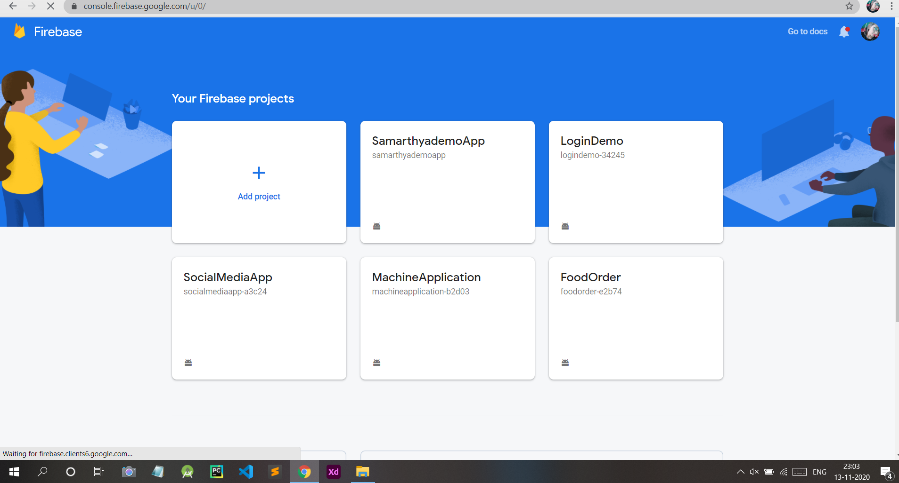

**Step 2:**Give a Name To your Project and Click On **Continue**Button.

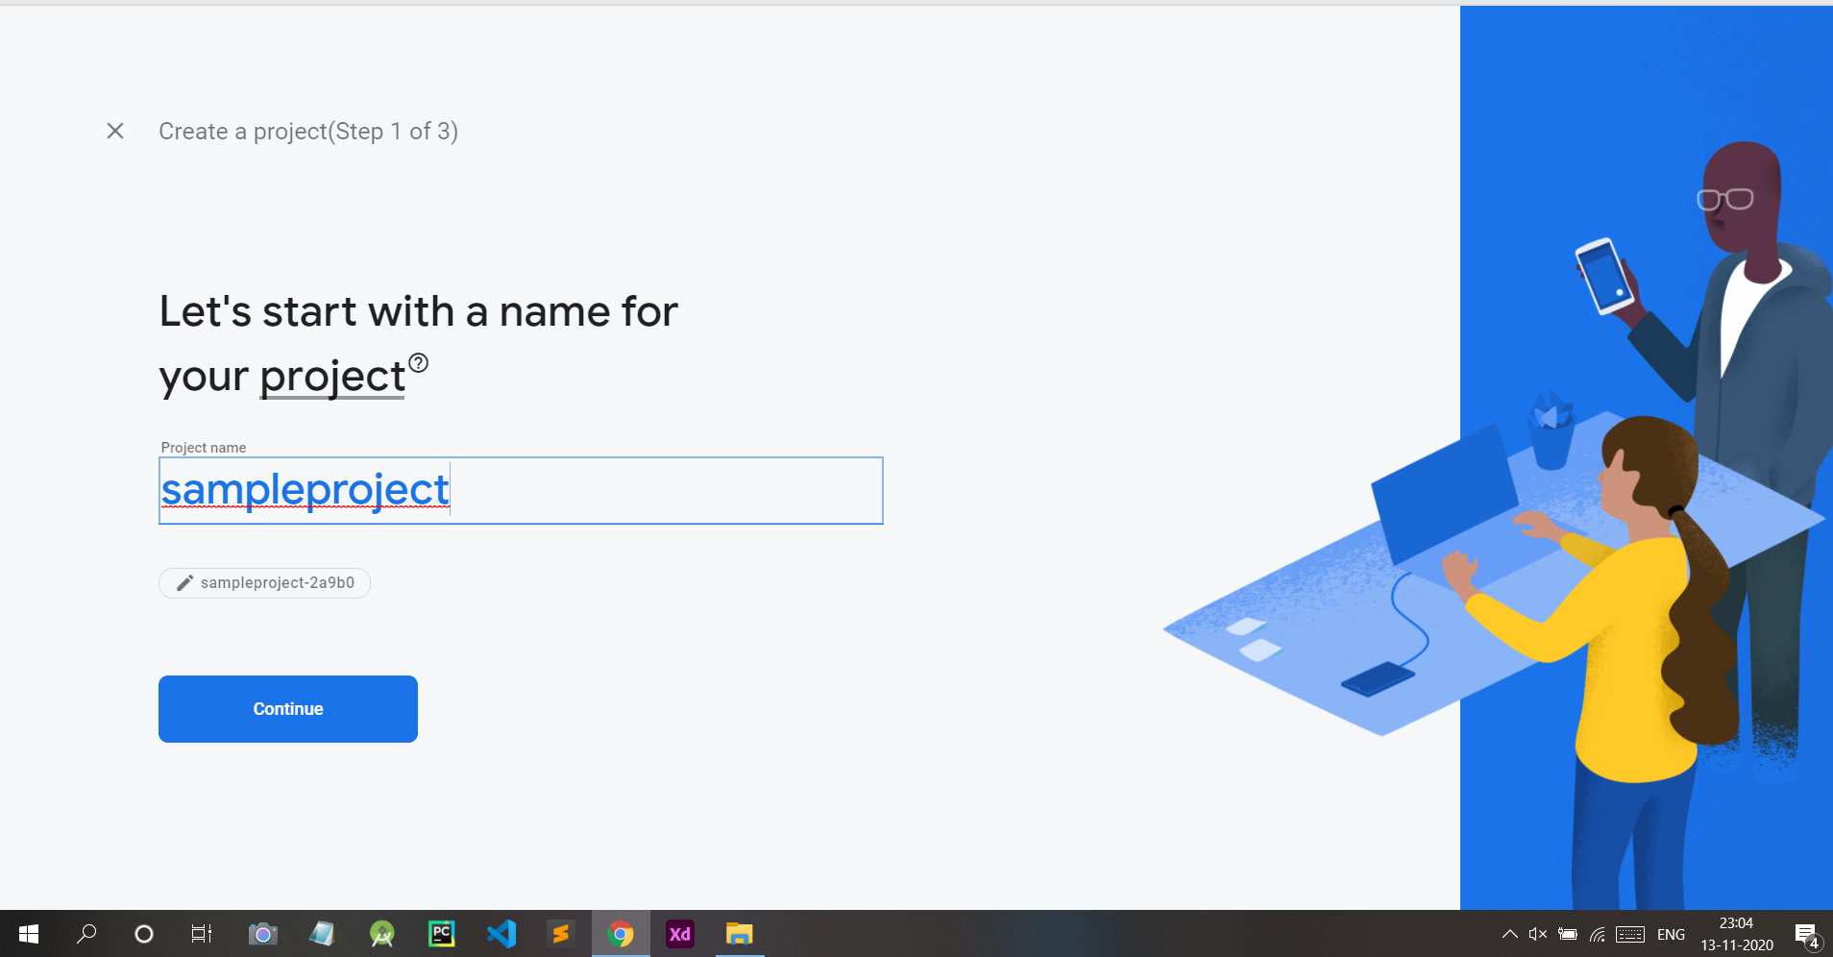

**Step 3:**Now Click On **Continue**Button.

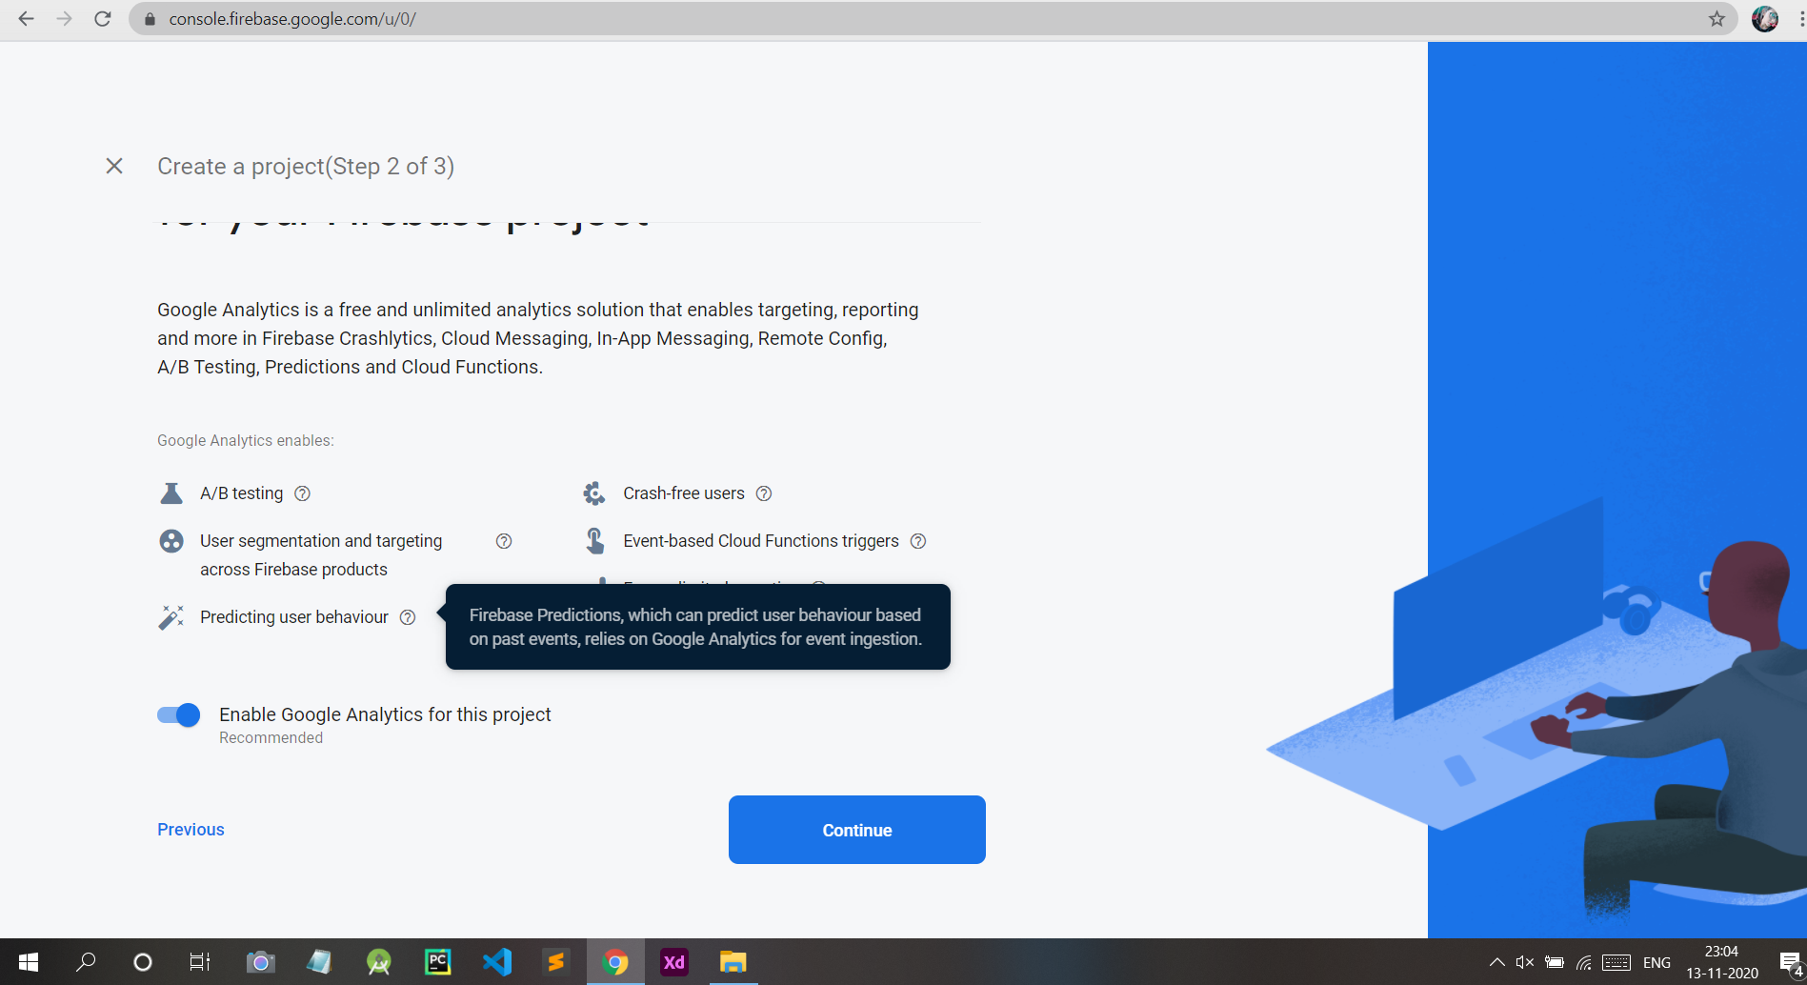

**Step 4:**Now Choose Default Account For Firebase and Click On **Create Project**.

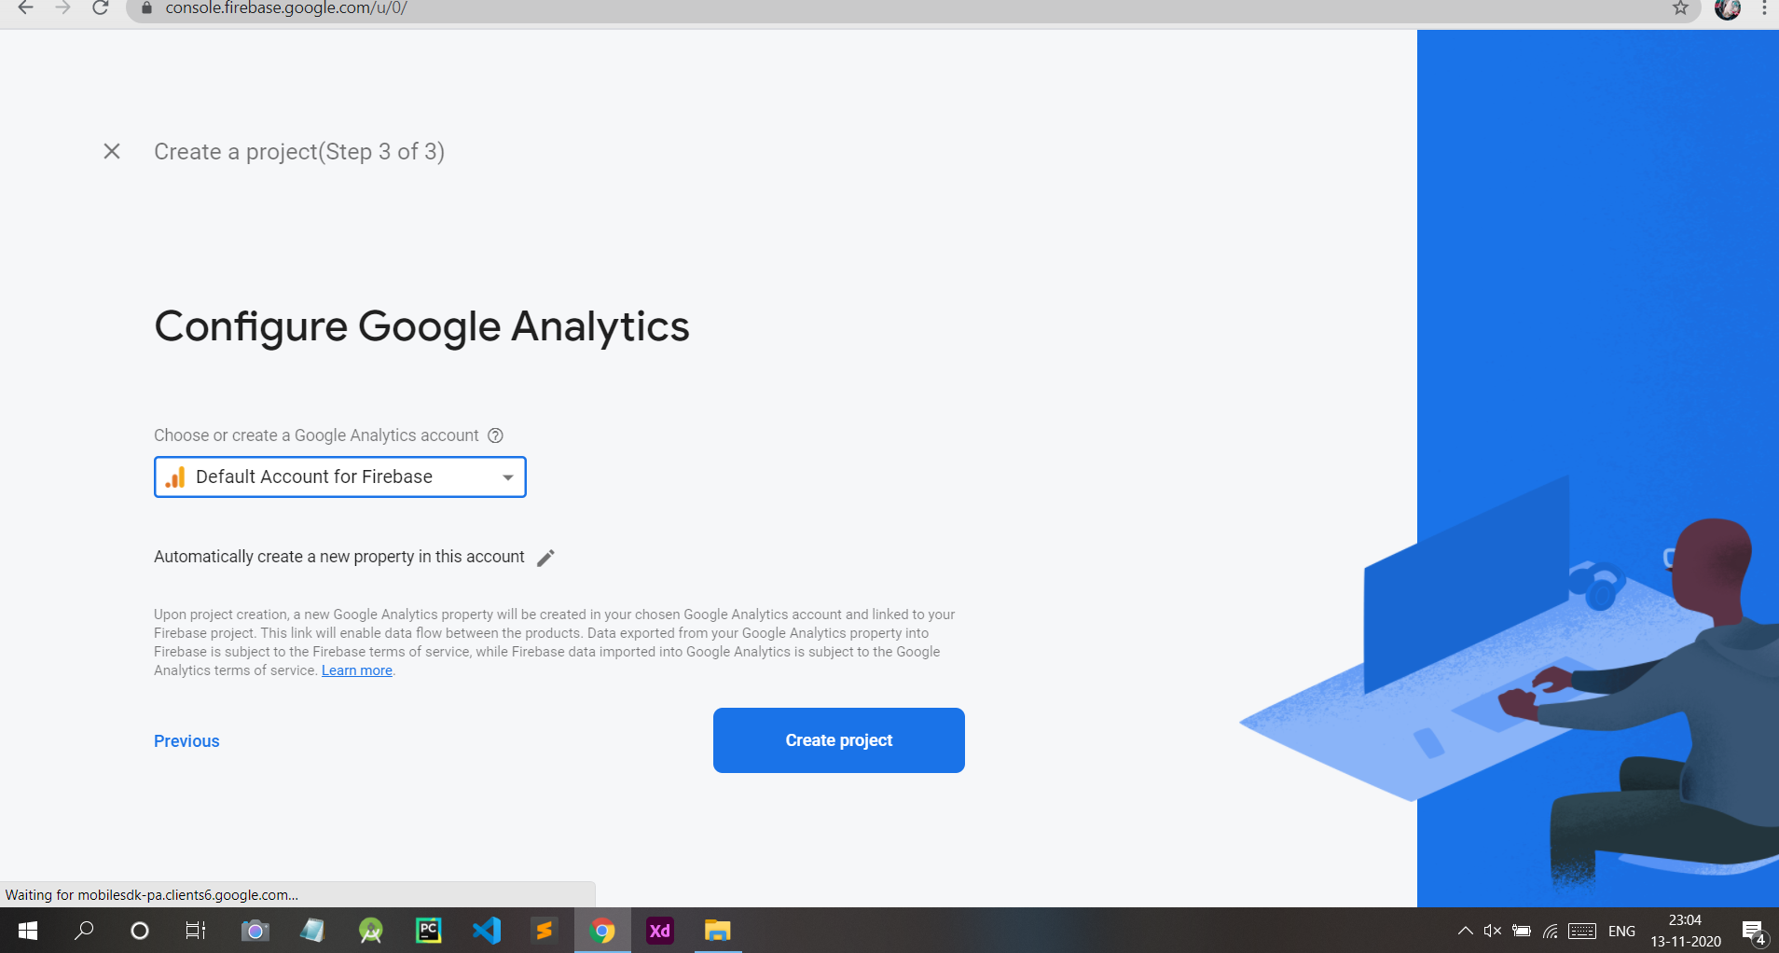

**Step 5:**Now Your Project is created. You are Good to Go. Click on **Continue .**

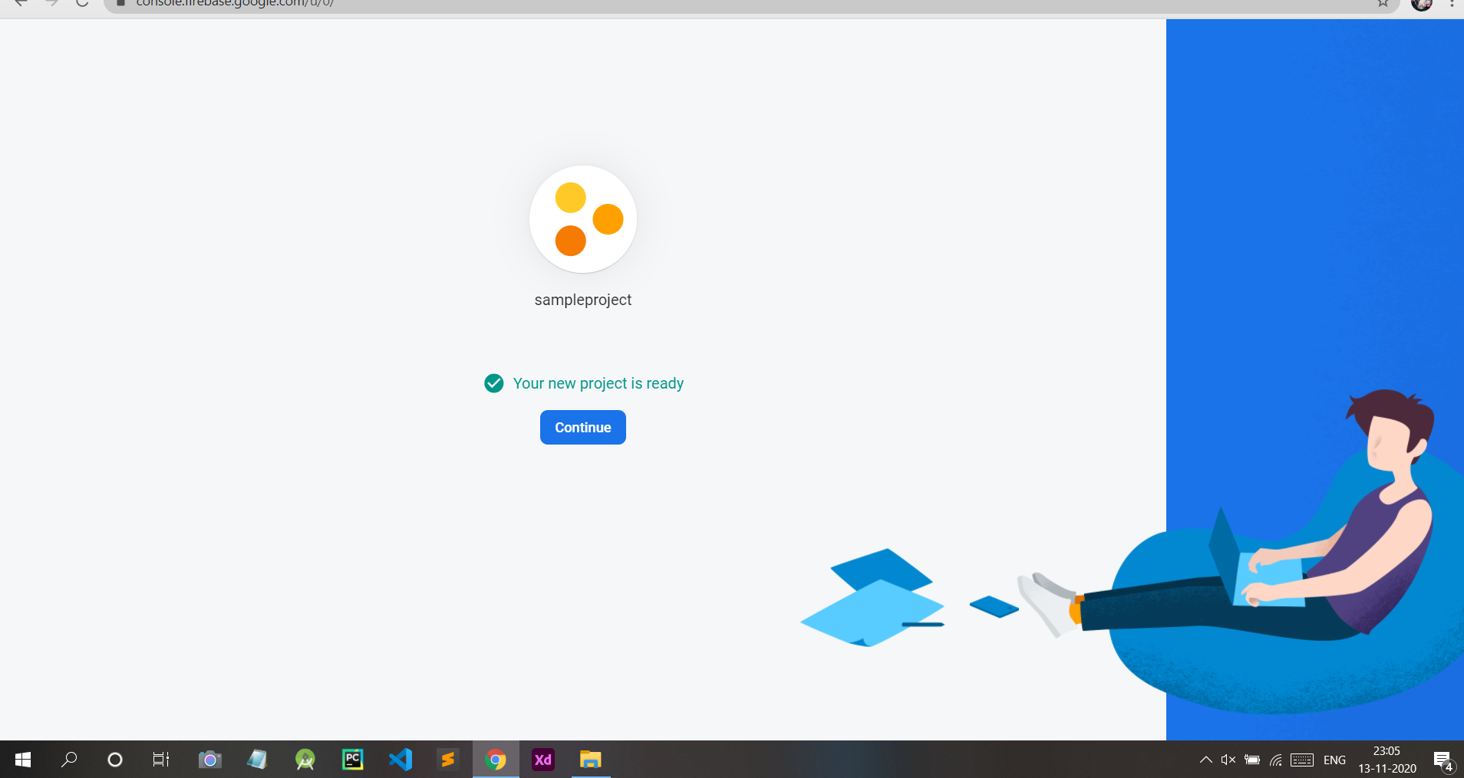

**Step 6:**Now Click On 3rd icon that’s **Web Button(</>)**.

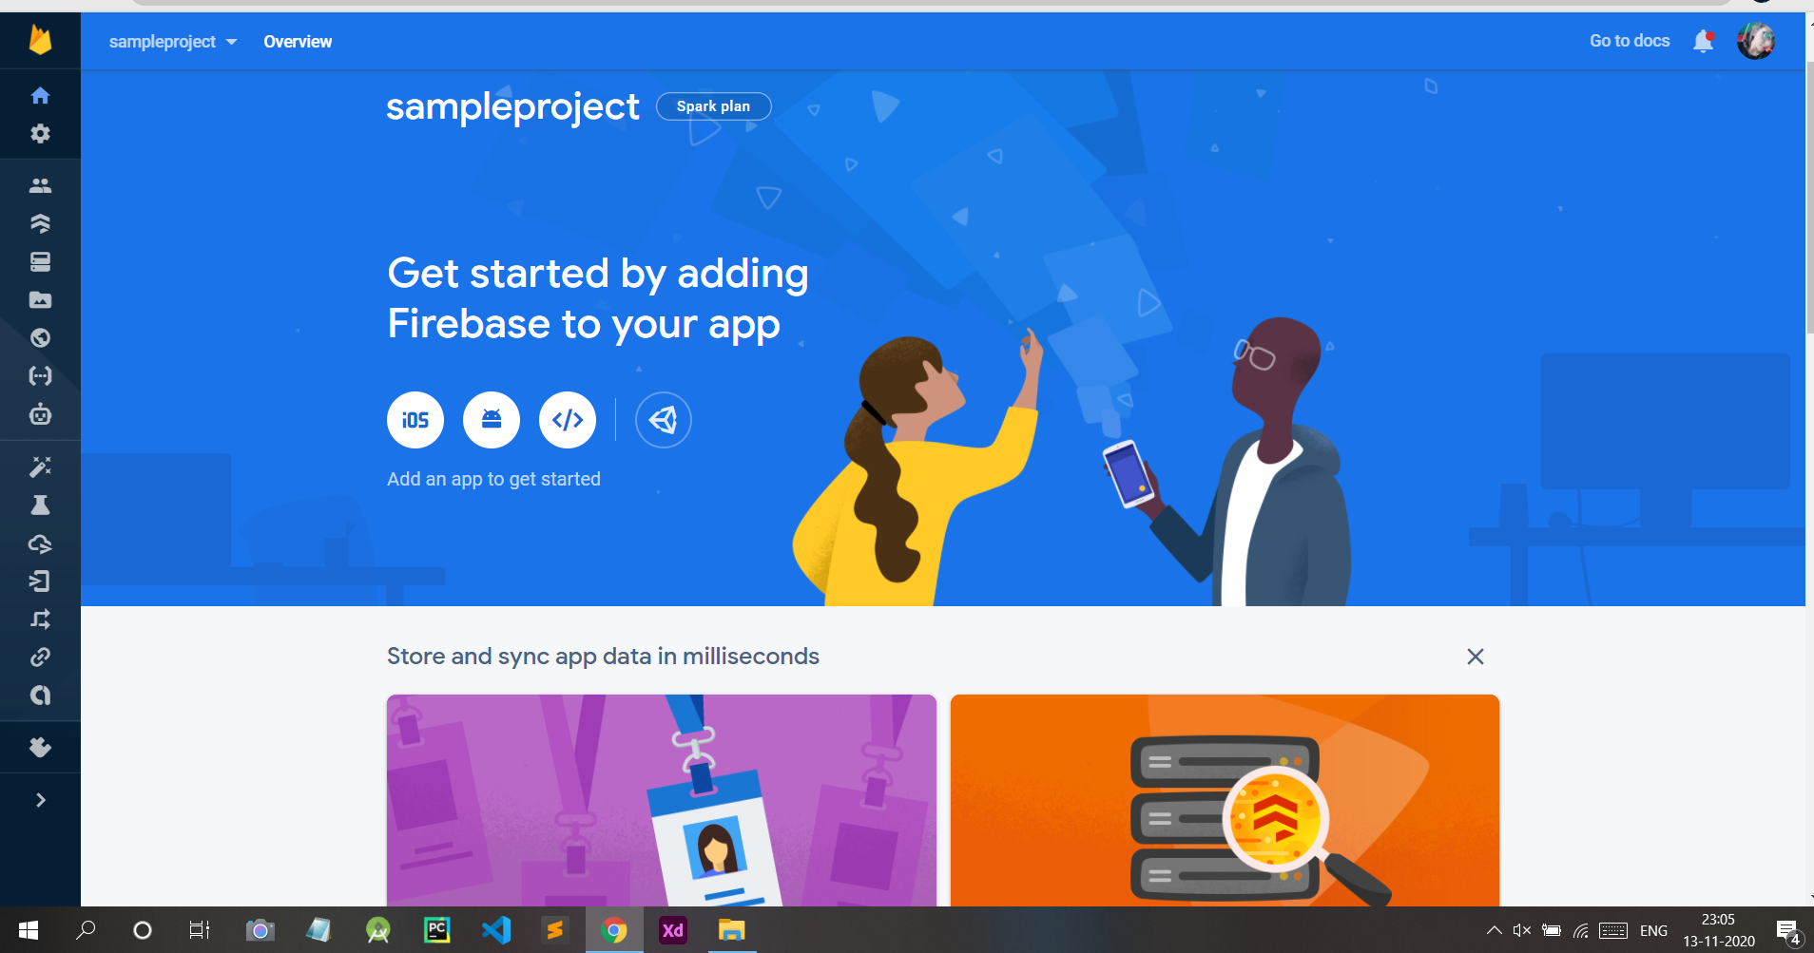

**Step 7:**Give a nickname  to your Web Project and Click On **Register App**

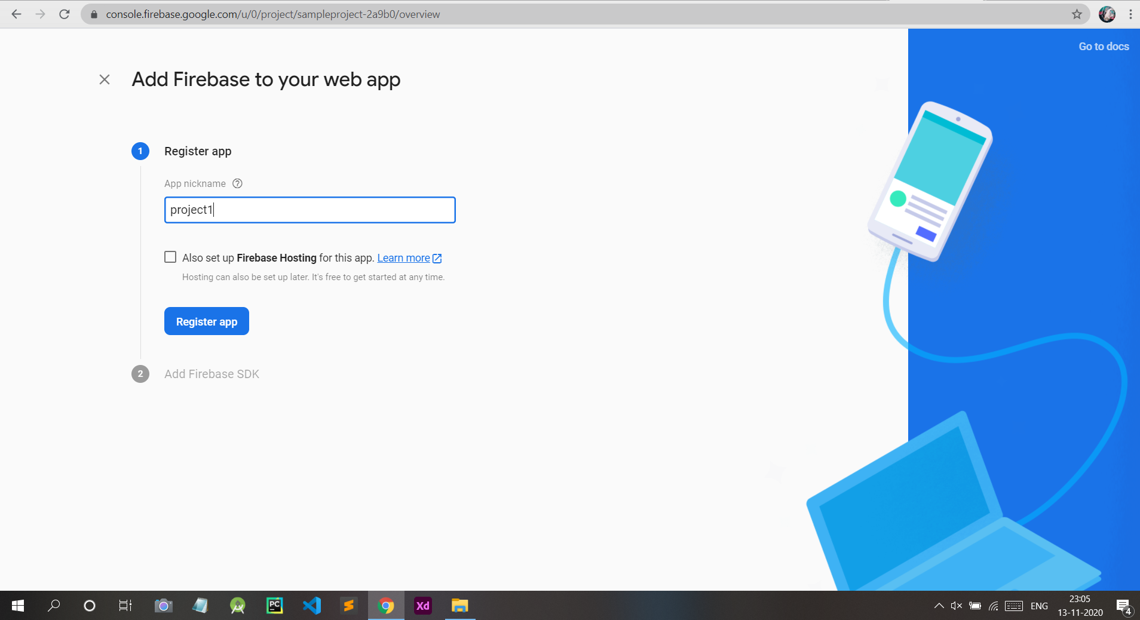

**Step 8:**Now you will see the configuration of your App like this. Copy this Code somewhere .You will need it later.

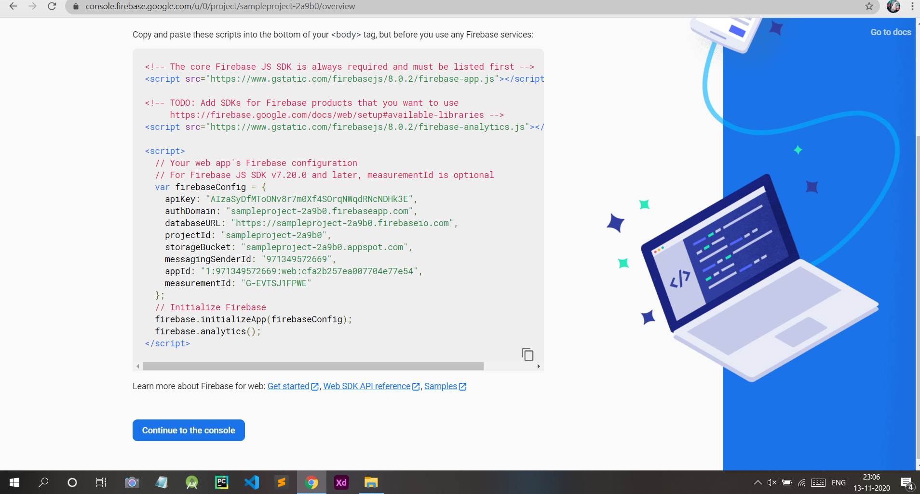

**Step 9 :** Click On The **Realtime Database**button As Shown In Figure.

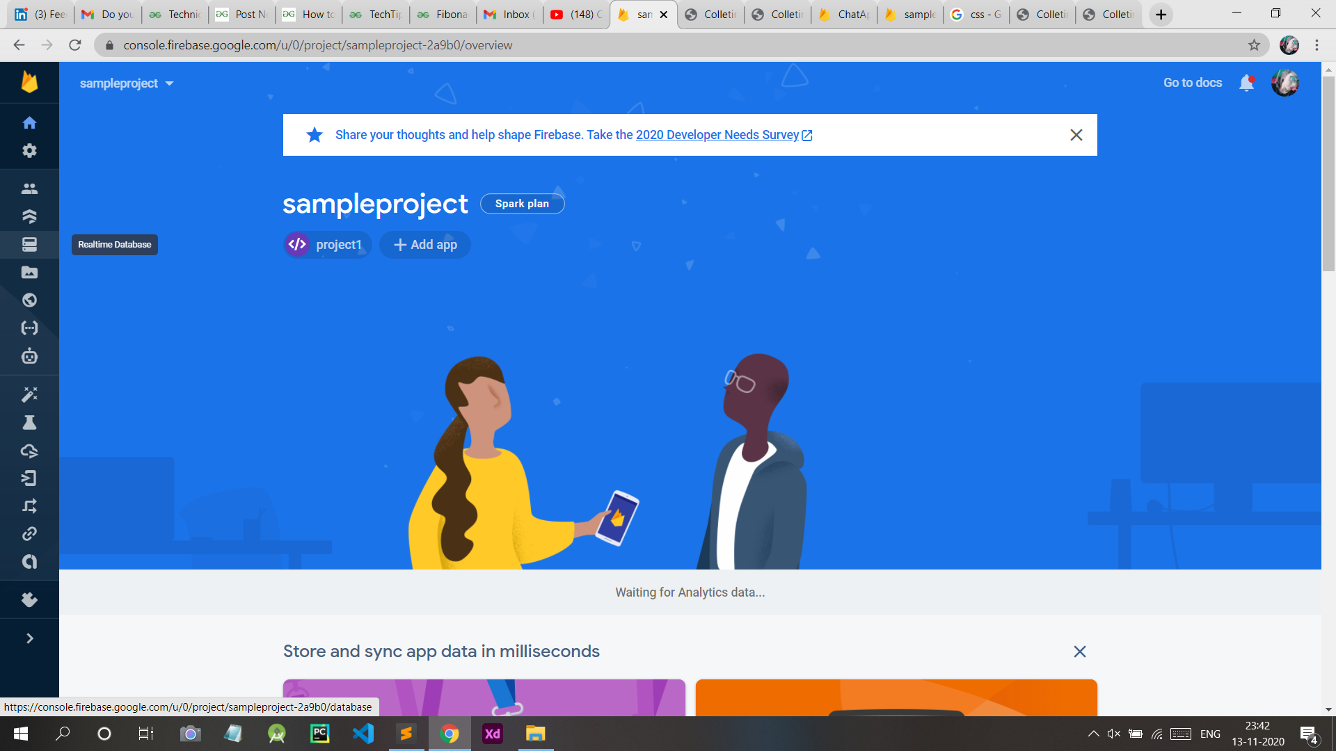

**Step 10:**Now Click On **Create Database.**

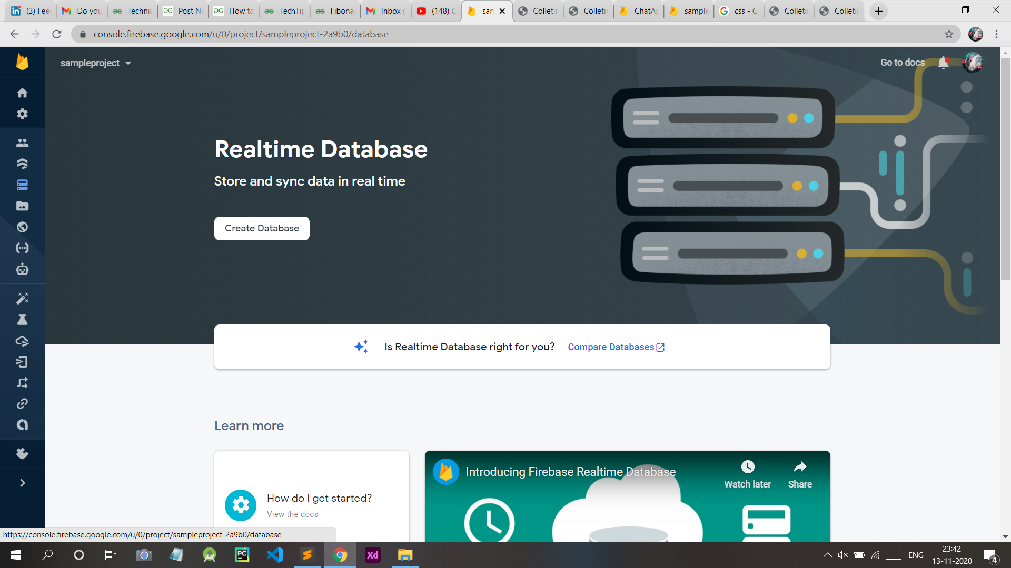

**Step 11:**Now Click On **Test Mode** and then Click On **Enable**.

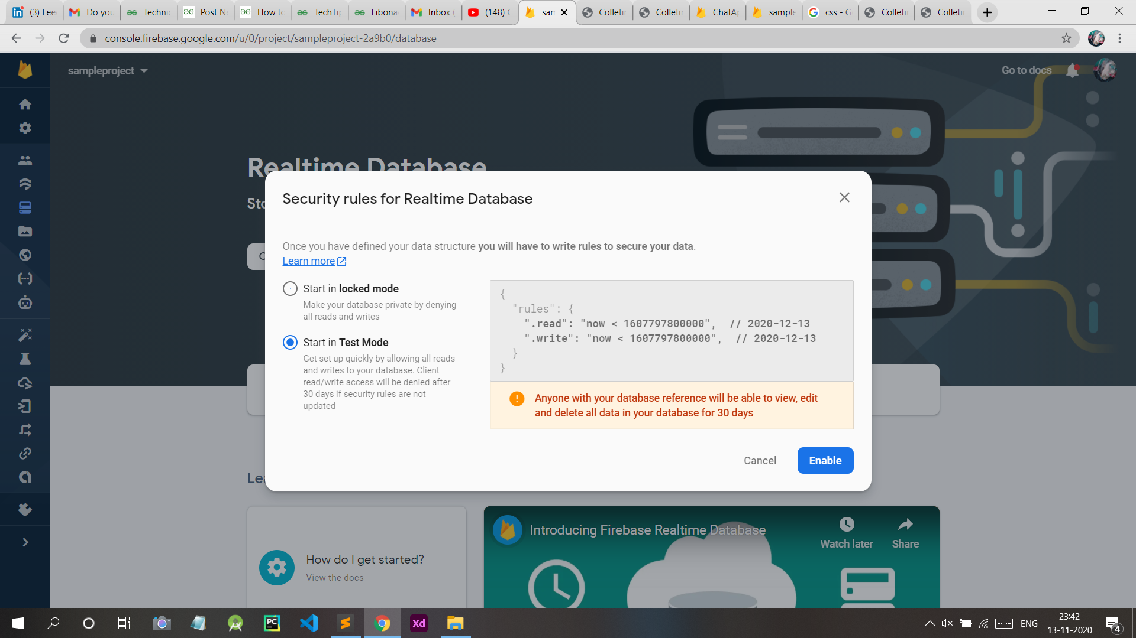

Now, We will Add Some Data and will try to Retrieve that using our Website

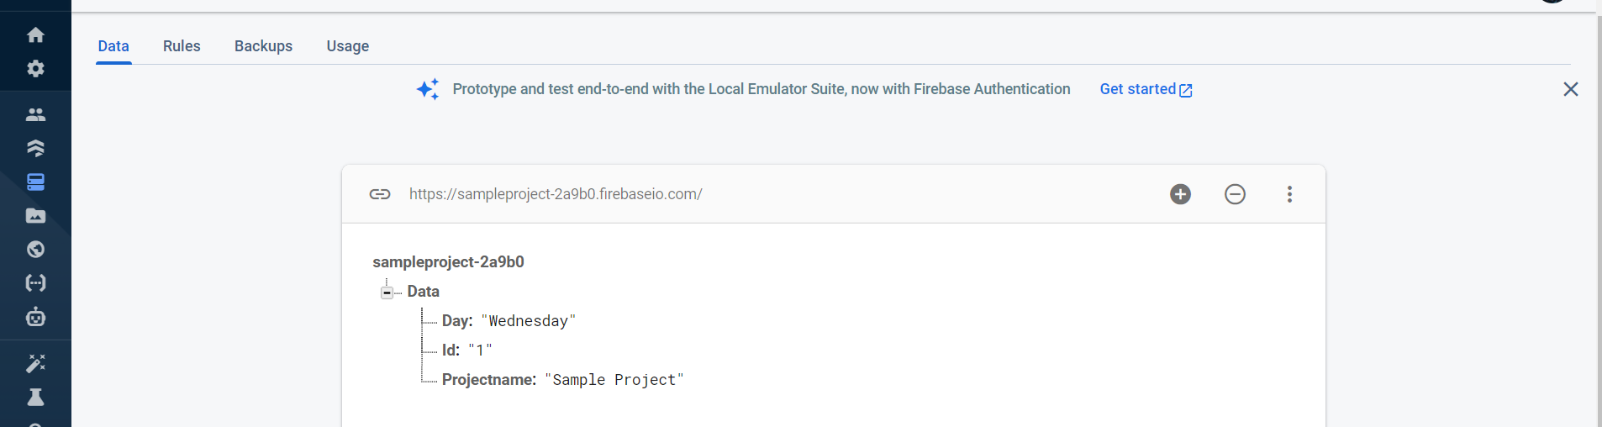

**Integrating Firebase Database to Django Project –**

Now, I hope that you have already create a project in Django. If not then Refer to [How to Create a Basic Project using MVT in Django ?](https://www.geeksforgeeks.org/how-to-create-a-basic-project-using-mvt-in-django/?ref=lbp)Since we are using firebase as Database , We need to install pyrebase . For this Type the following Command in terminal

$pip install pyrebase4

Create a views.py file in your project directly. The Structure should be like this .

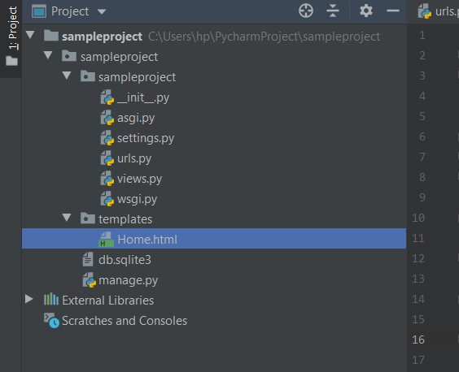

**Urls.py file**

* Python3

|  |
| --- |
| from django.contrib import admin  from django.urls import path  from . import views    urlpatterns = [      path('admin/', admin.site.urls),      path('', views.home),  ] |

**Views.py**

* Python3

|  |
| --- |
| from django.shortcuts import render  import pyrebase    config={      apiKey: "Use Your Api Key Here",      authDomain: "Use Your authDomain Here",      databaseURL: "Use Your databaseURL Here",      projectId: "Use Your projectId Here",      storageBucket: "Use Your storageBucket Here",      messagingSenderId: "Use Your messagingSenderId Here",      appId: "Use Your appId Here"  }  firebase=pyrebase.initialize_app(config)  authe = firebase.auth()  database=firebase.database()    def home(request):      day = database.child('Data').child('Day').get().val()      id = database.child('Data').child('Id').get().val()      projectname = database.child('Data').child('Projectname').get().val()      return render(request,"Home.html",{"day":day,"id":id,"projectname":projectname }) |

**Home.html**

* HTML

|  |
| --- |
| <!DOCTYPE html>  <html lang="en">  <head>      <meta charset="UTF-8">      <title>Sample Project</title>  </head>  <body>  <H1>  Project Name is {{ projectname }}      </H1>  <br/>  <h2>  Project Id is {{ id }}      </h2>  <br>  <h3>  Day {{ day }}      </h3>  <br>  </body>  </html> |

Now move to your project directory and run our project using the given command :

python manage.py runserver

**Project Output will be as Follow –**

